* **Svn checkout <URL> 🡪 to check out the code**

This checkout command created workspace

* **Svn status 🡪 it shows the status of workspace**

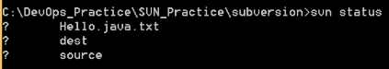

It shows ‘?’ symbol for the files which are not added

* **Svn add <filename> 🡪 used to add the files to workspace**
* **Svn add * 🡪 to add all the files**
* **Svn commit <filename> -m “commit message” 🡪 this will push the code to SVN. Because the client connects to the browser**
* **Svn commit -m “commit message” 🡪 this command will commit all the added files**

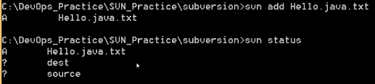

Once we add the files, we can see A symbol

* **Svn delete <file name> 🡪 to delete the file or a directory**

After deleting, we need to commit the changes again

* **Svn update 🡪 to update the workspace with repository**
* **Svn log 🡪 to check the log**
* **Svn update -r1 🡪 to check what happened on particular revision. With this command, we can see the changes on workspace**

Revision is a unique number happens every commit

* **Svn help 🡪 to check all the commands of svn**
* **Svn mkdir 🡪 to create the directory in svn**
* **Svn info 🡪 this will give the information about svn repository**

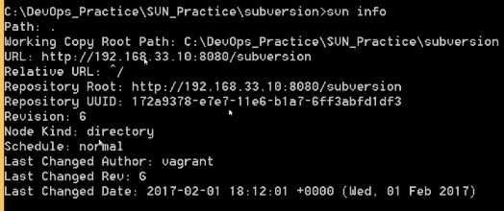

If we made any changes to a file and want to revert, then we can use revert command as below

* **Svn revert <file name>**

Revert can also be used to unadd the added file or folder as below

* **Svn revert <file name> 🡪 to unadd the added file**
* **Svn revert -R <folder> 🡪 to unadd the added folder**

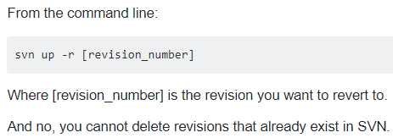

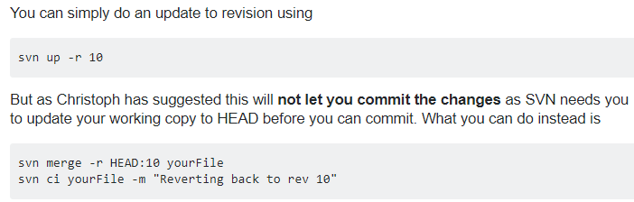

* It seems, we cannot delete any revision in SVN

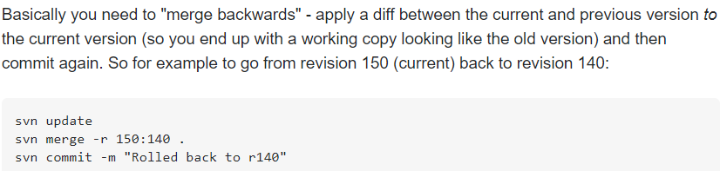

We can pull the code till particular revision in SVN by using @ symbol while pulling the code as below.

* **SVN_URL@revision**
* **Svn move devops devops1 🡪 to rename the file**
* **Svn diff <file name> 🡪 to see the difference between two revisions**
* **Svn diff -r2:5 <file name> 🡪 to see the difference between revision2 and 5 for a particular file**

We can’t commit or pull the code without workspace

And if we want to push a file without workspace, then we need to use import command

* **Svn import <file name> <URL for svn/file name> -m “commit message”**

Svn import command works like direct commit on repository

* Import command cannot be used of second time as below



In the same way we can use export command to pull the file

* **Svn export <URL of repository/file name>**

With export, we can just download the file but can’t work on that. This is the difference between checkout and export



Export can be done using UI as well.

**Tagging:**

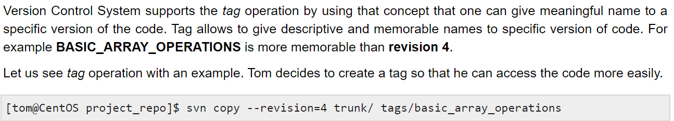

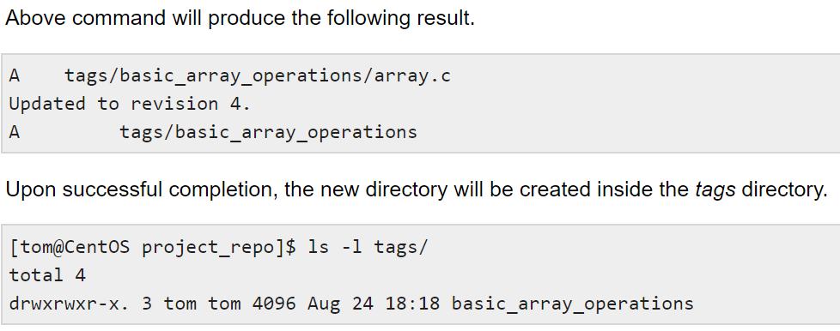

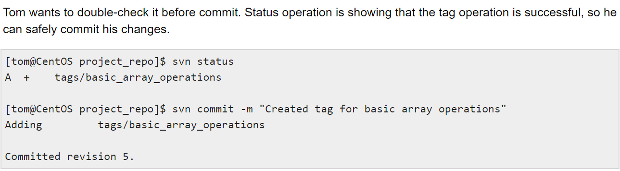

We can also do this from tortoise SVN

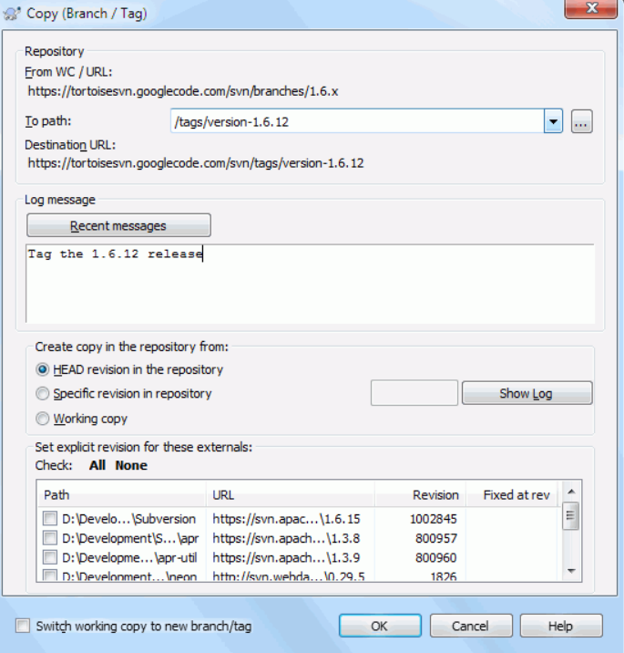

Tags folder looks like below.

